Seneca Solutions

Consulting Services Manager: Ms. Denise Chilton

70 The Pond Road

Toronto, ON M3J 3M6

www.senecasolutions.ca

416-491-5050

April 10th, 2018

Tutor Pro

Owner: Ms. Lhisha Bennett

1769 Shawnigan-Mill Bay Road

Shawnigan Lake, BC V0R 2W0

www.tutorpro.net

250-900-5157

Dear Ms. Lhisha

This Analysis Report will give you a background about the solutions and recommendation that we will provide to you. Our team has a strong background in Technological environment and we hope to satisfy your needs.

Learning Management System (LMS) is expanding more than ever due to the fast improvement of technology. There are many LMS that are free and available to use in the market, but they are not reliable, not stable and lack many educational features. We don’t want you to face issues while using it. LMS is a very competitive field due to the numerous Learning Management Systems out there.

Technology is very helpful to humans through the numerous amount of applications that support us. With an LMS, school will be easier to get in touch with and make class activities better than ever. Technology has no limit and same goes for education, therefore we would like to take this opportunity to help you bring education to a new level.

If there is any concern, question, report’s information or solution/recommendation problem, I would be pleased to help you address the issue.

Sincerely,

Denise Chilton

The recent partnership between Tutor Pro and the Southern Vancouver Island School Board (SVISB) not only gains Tutor Pro an increasing number of customers (tutees) but also an investment of $500,000 to adopt a Learning Management System (LMS). As an expanding business, Tutor Pro is looking for an LMS that is capable to support its growth amongst other requirements.

After carefully analyzing the requirements of Tutor Pro, we conducted research on LMS that are currently available in the market to best fit Tutor Pro's needs. With the budget limitation in mind, we studied both open-source and proprietary LMS. The criterions we searched for were mass cloud computing and storage capabilities, compatibility. The 4 LMS that fits most if not all of Tutor Pro’s requirements are discussed in this report, they are Blackboard, Moodle, Litmos, and Google Classroom.

Our study on these 4 LMS including the following aspects: development, usability, platform and lastly training and support.

Development features

· All 4 LMSs have developer API and third-party app integrations.

· All but Google Classroom are incorporated with Sharable Content Object Reference Model (SCORM), which allows the reuse of content cross multiple software.

Training and Support

· All 4 LMSs provide online support and documentations customers can download from the internet.

· Blackboard and Litmos, also provide 24/7 live chat and in-person training for their customers which is great for organizations with limited technical personnel.

Usability

· All 4 LMSs support single sign-on and asynchronous learning. These two technology allows users to access all granted functions of the LMS with one-time sign-on at any time they want.

· All but Google Classroom supports synchronous learning, blended learning, webinars, and online testing. Synchronous learning can be achieved via webinars, a form of web conference, amongst other methods. Synchronous learning is a great way for virtual classes.

· All but Litmos support social learning and gradebook, which is a required function by Tutor Pro. Social learning allows students to interact with one another online via live chats, wikis, etc.

· All but Blackboard support gamification, which allows instructors to create game like activities for students to interact with.

Platform

· Blackboard and Moodle are available in forms of installation executables for both OS and Windows systems and mobile apps for Android, iOS and Windows.

· Litmos and Google Classroom are only available on mobile devices and they both only support Android and iOS systems.

Deployment and Pricing

· All 4 LMSs are enabled with cloud archiving and are accessible via browsers.

· Both Blackboard and Litmos are propriety LMSs, which means they both requires a licensing fee.

· Moodle and Google Classroom are completely free, on the other hand, however Moodle is open source and requires extra technical support from the client side and Google Classroom is freemium and has limited functionalities.

Based on the data collected, we recommend Blackboard as the go-to LMS for Tutor Pro for the following reasons. Since Tutor Pro has limited number of technical personnel, an open source LMS is not a good choice. Open source LMSs, like Moodle, requires a large amount of technical support, including but not limited to security, from the client side and may require extra cost for cloud storage. Litmos and Google Classroom’s incompatibility with PCs and laptops does not meet Tutor Pro’s requirement for students to access the LMS via multiple platforms. Moreover, information published by Missouri State University suggests the licensing fee for 5 years is around $135,000, which is well within the budget of Tutor Pro.

**Table of Contents**

1. **Transmittal Document / Cover Letter ..……………………………………………… 1**
2. **Front Page ...……...……………………………………………………………………… 2**

a. Title Page ...………………………………………………………………………. 3

b. Executive Summary ...…………………………………………………………... 4

c. Table of Contents ..………………………………………………………………. 5

d. List of Illustrations ……………………………………………………………….. 6

e. Glossary ………………………………………………………………………….. 7

f. List of symbols …………………………………………………………………… 8

**3. Report Details ……………………………………………………………………………. 9**

a. Introduction ……………………………………………………………………….. 10

b. Client Requirement & Assess Criteria …………………………………………. 11

c. Solutions Offered ………………………………………………………………… 12

d. Comparison ………………………………………………………………………. 13

**4. Report Conclude ………………………………………………………………………… 14**

a. Summary & Interpretation ………………………………………………………. 15

**5. Recommendations ……………………………………………………………………… 16**

a. Solution Recommended & Justification ……………………………………….. 17

b. Implementation Details ………………………………………………………….. 18

**6. Back Matter ………………………………………………………………………………. 19**

a. References / Word Cited ………………………………………………………... 20

**List of Illustration**

1. Blackboard User Interface ………………………………………………………………… 8
2. Moodle User Interface …………………………………………………………………….. 9

# **INTRODUCTION**

This report presents the different Learning Management Systems (LMS) that are suitable to your needs. We understand that your company is looking for a long-term software with the specific requirements that will bring eLearning to the next level. Knowing that Tutor Pro has recently partnered up with SVISB the users of the Learning Management Systems will be school students, adult learners who wish to complete their high school equivalency, and teachers. With multiple target audience, the software must be fun, flexible with an easy to use user interface all whilst supporting a wide range of devices. With your requirements in mind, we have reviewed various Learning Management Systems that will strongly support the education process of students.

We have narrowed the options down to four Learning Management Systems that meet your budget:

· Blackboard LMS

· Moodle LMS

· Litmos LMS

· Google Classroom

In this report, we will go over the usability, reliability, deployment, and the portability of the learning management systems. The comparisons made will give you a good understanding of the eLearning technologies and the advantages and limitations of the Learning Management Systems Listed above.

**Client Analysis**

Our client, Tutor Pro, is a tutoring company that is about to expand dramatically. To accommodate their future expansion and plans, they have outlined a series of requirements they would like a Learning Management System to meet. They have received investments of $500,000 to spend on the Learning Management System, and have requested that in the long term, the system would be able to do the following:

· Support in-person and online classes of up to 20 students

· Store data online for 250 instructors and 15000 students

· Create assignments and be able to grade and give feedback online

· Have integration with other educational tools and content providers

· Allow for co-teaching

· “Fun, flexible, and easy to navigate” User Interface.

· Software training for instructors and customer support.

· Support for a wide variety of devices, as we have no way of knowing what every student will use.

Knowing all of this, it seems that these requirements fall into three distinct categories. Support for online learning, which will include the support for online classes, data, assignments, and devices, as well as the co-teaching. All these sections are similar and can be analyzed in the supported features section. Integration with other educational tools falls under a similar section to the support for online services but relies not just on the Learning Management System itself, but also on other systems, and that distinction is remarkable enough to consider it a separate category. The logistics and potential cost of implementing other systems within your own would be harder for a smaller Learning Management System. And finally, User Interface will stand as its own category as well, considering it is both broad and important enough to be ranked by itself. In total, this means there are three major areas the client is looking for:

· Implementation of services: Does it have the features requested for use?

· Integration of other tools: Does it support this?

· User Interface: Is it “fun, flexible, and easy to navigate?”

In addition, Security will be considered in our Analysis as to protect the information and privacy of our clients.

All Learning Management Systems to be discussed will be Analyzed on these three categories.

**Learning Management Systems**

**Blackboard:**

Blackboard, made by Blackboard Inc., is a Learning Management System designed by Blackboard Inc, a company whose mission is to “partner with the global education community to enable student and institutional success, by leveraging innovative technologies and services” (What is Blackboard). Blackboard is a proprietary LMS that was first released in 1998 but has since added functionality that makes it less of a proprietary system (What is Blackboard). This means that while being released extremely early in the development of Learning Management Systems, Blackboard has been continually updated and has changed with the times. Having had the most time understand the needs of a Learning Management System, Blackboard supports a wide variety of functionality, integrates many other tools, and generally is one of the more expansive Learning Management Systems. Blackboard is supported by it’s online web service which most if not all of it’s functionality is accessible through and has mobile apps for additional support (Blackboard Mobile App). In addition, there is support for other tools, including Moodle itself, another LMS to be covered(Moodlerooms). The UI is customizable for each class and student, so they can make blackboard easy to use for them. As it is customizable, the attached image is one of many configurations available to use and should only be used as a frame of reference.

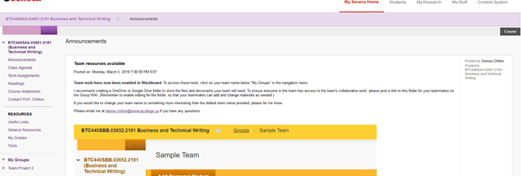

**Figure 1.1 –** An example of the Blackboard User Interface.

**Moodle:**

Unlike Blackboard, Moodle, made by Moodle HQ, is an open source Learning Management System (Yilmaz, 21). Moodle has also been in development for quite some time and being open source and free has allowed Moodle to gain some recognition and gain a favorable following to work on Moodle and make the systems contained within it more modern (About Moodle). Moodle is also highly customizable and flexible, along with being free, multilingual, and web based, so it can be used on any device, much like Blackboard. Moodle, being an open source Learning Management System, can be extended and customized specifically for the client, and plugins can be utilized to provide the functionality the client is looking for. An example for a Moodle UI, which can be changes, is shown in Figure1.2, but this Moodle UI needs to be created by the client in most cases.

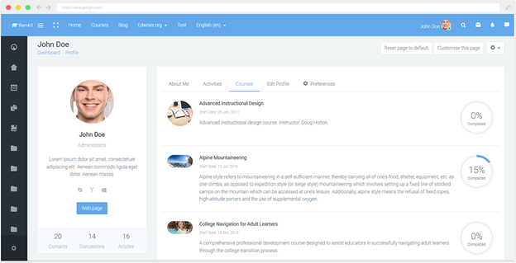

**Figure 1.2 –** An example User Interface for Moodle

**Litmos LMS:**

Litmos LMS, made by Callidus Cloud is a different style of Learning Management System when compared to the previous two results. Litmos is known as a cloud-based Learning Management System, meaning nothing needs to be installed, and can be accessed from devices that can use the internet (Dobre, 319). It is marketed as the “easiest to use Learning Management System” (Litmos LMS). There are apps supported on IOS and Android, naturally supports employee training, and is designed to “build and deliver quality courses quickly” (Litmos LMS). Litmos has natural support for google, Dropbox, Freshdesk for customer service, as well as many other types of apps through the “Litmos Marketplace” (Connected Applications & Integrations). The UI can be customized with Bootstrap, but that requires knowledge of CSS and HTML (Connected Applications and Integrations). Figure 1.3 will show an example of Litmos’ UI with Bootstrap Integration.

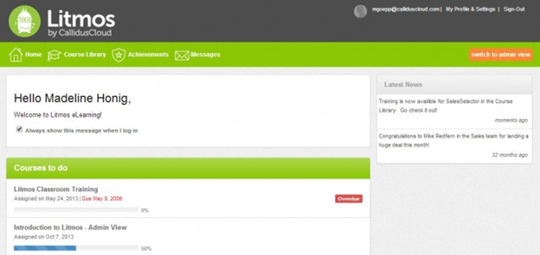

**Figure 1.3 –** An example of a customized Litmos UI with Bootstrap.

**Google Classroom:**

Google Classroom, made by Alphabet Inc, is not a traditional LMS as it is more a way of structuring their pre-existing services, such as google drive, docs, and slides, to better suit a class environment. The ways it does so, however, make it a contender as a solution. Depending on how the information is being handled currently, it may be an easy switch if google products are already in place. It integrates other tools, and those tools already have the capability for plugins to extend their functionality and include other services, like citation helpers for Google Docs (Transform your Classroom). Headers can be customized for Google Classroom, but the layout remains static in most cases, across web and mobile apps (Transform Your Classroom) Figure 1.4 will show an example of Google Classroom’s layout.

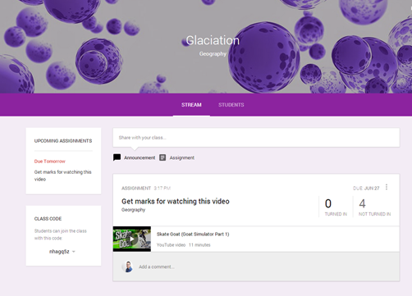

**Figure 1.4 –** An example of a base Google Classroom Layout.

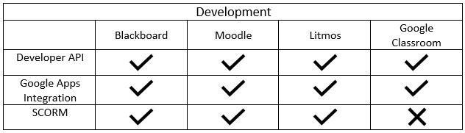  
**Development Key Features & Importance  
Developer API (Application Programming Interface):** “Sets of standardized requests that allow different computer programs to communicate with each other. APIs establish the proper way for a developer to request services from a program” (Britannica). They allow programs and the developer to communicate with the system across different computing platforms (Britannica). A developer API allows developers and LMS management software to access different features of the LMS programmatically. The developer/management software can update, post, view, and delete features such as announcements, course grades, assessments and many more.

**Google Apps Integration:** Allows the LMS to integrate with the apps and services provided by Google. With google integration, students will gain access to features like Google calendar, drive, Gmail, Google+, hangouts and many more. These features will increase student’s productivity by taking advantage of the services provided by both Google and the Learning management system. Services like Gmail, Google+ and hangouts will also help provide social learning and apps such as Google slides, docs, and sheets can provide students with software needed to complete their work with ease of access.

**SCORM (Sharable Content Object Reference Model):** Created by Advanced Distributed Learning (ADL) to address the challenges of reusability, durability, and the ability to exchange information between multiple software (ADLnet.gov). It is designed to meet the high-level networking standards and browser-based e-learning content (ADLnet.gov). SCORM is a set of technical standards for e-learning software products. It tells programmers how to write their code so that it can “play well” with another e-learning software (scorm.com). With SCORM, the LMS administrators and teachers will be able to create sharable content that can be reused in different contexts (SCORM.com)

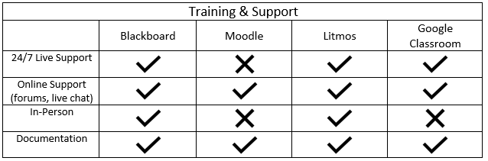   
**Training & Support Key Features & Importance  
24/7 Live Support:** 24 hours and 7 days a week online live support. When working with data and learning management system there is a possibility that an upload or a bug can cause the system to crash. The live support can help fix and patch issues when needed.

**Online support:** Set of instructions and support provided online through forums and electronic communication such as emails, live chat, and document sharing.

**In-person:** When getting started with the LMS, teachers and the LMS administrators will likely need help in setting up and understanding the features and concepts around using the LMS. In-person training and support can ensure staff and administrators know how things work.

**Documentation:** Official information about the LMS and the developers guide. The administrator or developer can use the documentation to know how to use the API provided by the LMS as well as the features included within the LMS package.  
  
  
  
  
  
  
  
  
  
  
  
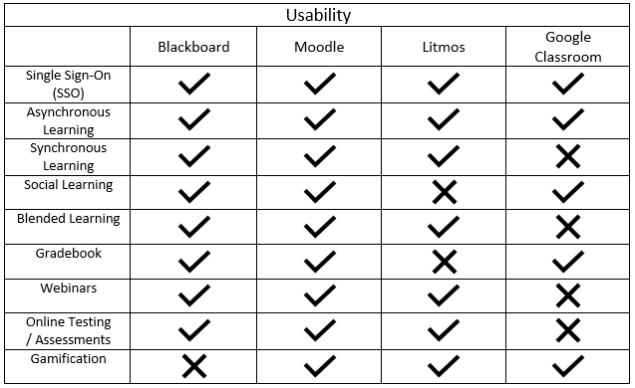   
**Usability Key Features & Importance**  
**Single Sign-On (SSO):** A session and user authentication service that allows one set of login credentials to access multiple applications, logging user activities, and monitoring user accounts (Rouse). All services that are given rights to authenticate the user with single sign-on eliminate prompting users for login credentials (Rouse). This has become a common feature in LMS due to all the different apps integrated into the LMS.  
https://searchsecurity.techtarget.com/definition/single-sign-on  
Asynchronous Learning: When students are undertaking the same course of study but accessing the learning materials and interacting with the teachers at different times (Wallace). This allows the students to learn at their own pace.  
Synchronous Learning: When students are undertaking the same course of studying and interacting with the teacher at the same time (Wallace). This is usually possible with webinars or video conferencing.

**Social Learning:** When students learning from one another by observing and interacting with peers. LMS provide social learning through features like chat, file sharing, forums, question and answer forums and more.

**Blended Learning:** A combination of modes of learning (distance and face-to-face). It is when a student “a student undertaking a programme of study via a blended learning model of delivery will access much of the learning materials and much regular contact with their tutor and other learners online but will also attend at least one lesson or tutorial” (Wallace).

**Gradebook:** A way to keep track of all of student’s grade, teachers can stay organized by keeping all their marks online in the gradebook. LMS’ such as Moodle and blackboard have built in gradebooks which allow ease of access for both teachers as well as for students who want to see their own marks.

**Webinars:** A conference or collaboration held online. (E.g. online seminars)  
Testing / Assessments: Test or assessments will be accessible online to students for a period of time. This will allow teachers to test their students online without the hassle of coming to class.

**Gamification:** “The concept of applying game-design thinking to non-game applications in order to make them more engaging and effective” (Boyle). In this case, students are awarded for participation through ways such as upvotes, likes, stars and more.

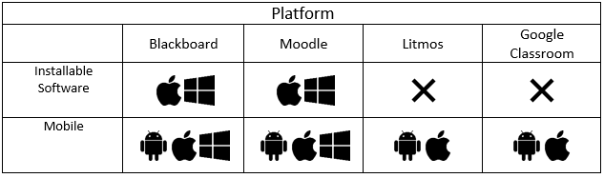   
**Platform Key Features & Importance**  
**Installable Software:** A application that can be installed onto the computer. This includes software to manage the LMS or simply access the LMS.

**Mobile Platform:** A lot of e-learning systems have gone mobile for giving students ease of access. There are three types of major mobile platforms (Android, iOS, and Windows), however, only Blackboard and Moodle provide mobile applications. Moodle has many different mobile application options since it is open source, however it is not guaranteed that it will work and function as well as the other proprietary and Google Classroom LMS.   
  
  
  
  
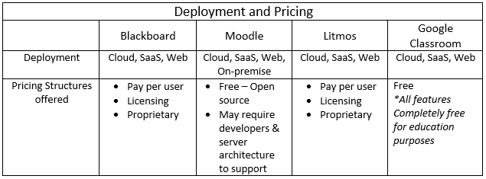  
  
**Deployment and Pricing Key Features & Importance  
Deployment:** All the 4 LMS offer Cloud integration and can be accessed through the browser (web). Blackboard, Litmos, and Google classroom offer state of the art security, however Moodle is open source and can have security vulnerabilities. This problem worsens with an on-premise server for students to access. If it is not correctly configured and implemented, the private information of students is vulnerable. Also, it takes length time frame to implement.

**SaaS (Software as a Service):** Software that is rented rather than purchased. Instead of buying applications and paying for periodic upgrades, SaaS is subscription based, and upgrades are automatic during the subscription period. When that expires, the software is no longer valid.  
  
**Cloud:** A communications network. The word "cloud" often refers to the Internet, and more precisely to some datacenter full of servers that is connected to the Internet.   
  
**Pay per User option:** Fee structure that involves paying for each person that uses the LMS, it is usually cloud-based where the vendor is responsible for hosting the LMS platform (Sharma). The advantages of Pay per user is regular updates and upgrades. The disadvantage is the cost, when dealing with thousands of users the cost skyrocket.  
Licensing option: Fee structure that involves paying monthly or annual licensing for the LMS (Sharma). The pricing includes user scalability.

**Proprietary option:** One -time purchase that grants the buyer access to the LMS platform. The advantage is that you do not have to worry about monthly or annual fees. The disadvantage is that you must pay for upgrades and updates to the LMS, also you may not be able to access it via the cloud (Sharma).

**Free option:** There are two types of free LMS, first is open source such as Moodle and second is Google Classroom which is a freemium LMS. Freemium LMS has very limited features compared to many of the other LMS that you have to pay for (Sharma). Moodle, is an open source LMS that is widely used in the education industry. The downside is that the implementation is very length and requires developers and servers/hosts.

**Conclusion**

When comparing the 4 Learning Managements Systems to the requested requirements of Tutor Pro Several factors need to be taken into account, and we must find the closest fit. All of the LMSs manage the task of having course managing tools for in-person as well as online classes of up to or past 20 students. They also all have cloud-based storage and data archives for up to 250 active instructors and 15,000 active students, as well as good integration with content providers and other educational technology tools. All the LMSs also allow for co-teaching in terms of asynchronous learning. However from this point on the LMSs differ in small and/or significant ways.

Blackboard, Moodle, Google Classroom and Litmos are able to create assignments, as well as grade those assignments though Litmos cannot post grades to assignments handed in person, whilst all the other LMSs can. All four LMSs are also able to give feedback to the student that the student may read after receiving their mark.

Blackboard’s user interface may not be “fun” per-se, as it’s default appearance is vary plain, Blackboard makes up for it in its extreme flexibility to its User Interface. Several tabs can be added to add functionality, including specialized tabs for group projects to ensure easy communication and collaboration. This flexibility to add and subtract functionality at the will of the teacher makes the user interface easy to navigate.

Moodle’s user interface colourful and easy to navigate, with a slight yet fun look to it and is just as flexible as Blackboard’s, however where it falters is it’s necessity for developers to create these changes for flexibility as Moodle is open source and allows for many changes to be made to it, but does not offer these changes itself.

Litmos and Google Classroom both also have a fun and nice look to them, however both lack the flexibility and customization allowed in Blackboard and Moodle.

Blackboard and Litmos both have 24/7 live support, online support, and documentation as well as in-person support. Since Moodle is open source and is hence free the only support readily available is online support, mostly forums, and documentation. Google Classroom has 24/7 live support, online support, and documentation.

Blackboard and Moodle can be installed for the Mac OS as well as the Window OS on computers, as well as android, Mac OS, and Windows on mobile devices. Meanwhile Litmos and Google Classroom do not have to be installed as they are managed online, however they can be installed on Android and Apple phones.

Blackboard’s greatest feature is its extreme flexibility to its User Interface as well as it being easy for teacher to edit said interface, however its weakest point is the design of the user interface not being “fun”.

Moodle is great for its flexibility and fun look to it, however it would require developers to upgrade and change the features/style.

Litmos thrives with being fun, however its biggest downfall is being unable to post grades to assignments done off of the software.

Google Classrooms is great for its integration of Google related content providers such as Youtube, however it also lacks the flexibility of changing the user interface to better suit the needs of Tutor Pro.

**Recommendation**

To better serve the needs of your Tutor Pro, Blackboard is the best option out of the 4 LMSs compared for the following reasons.

1. Blackboard can provide Tutor Pro all the functionalities required for the growth of the organization.

2. Blackboard is responsible for security and necessary updates in contrast to open source LMSs, such as Moodle, where Tutor Pro will be responsible for security and updates.

3. Blackboard provides cloud storage for Tutor Pro whereas open source LMSs requires Tutor Pro to either use a third-party cloud hosting or pay separately for cloud hosting.

As a proprietary LMS, Blackboard requires a licensing fee which is calculated based on the size of the institution and the duration of the contract. Blackboard does not publicly disclose the exact cost for a full package licensing, however Missouri State University has posted an estimated cost of a 5-year licensing renewal contract with Blackboard. The estimated total is $135,512.63 which covers a one-time fee and 5 years of licensing from 2014 – 2018 for Blackboard Expansion Package, including Blackboard Mobile for Learn. This estimation is well within Tutor Pro’s budget.

Although choosing an open source LMS can save the licensing fee, there are other hidden expenses. As mentioned, open source LMSs requires Tutor Pro to maintain the system. Additional fee for IT personnel will be created since Tutor Pro does not have enough technical experts for the task as well as cloud archiving.

With careful consideration of all the factors, Blackboard seems to be the most suitable LMS for Tutor Pro.

Implementation of the TutorPro software:   
  
After selecting which learning management system is best for TutorPro the next step will be to reach out to the LMS team and get started. With Blackboard they will ask TutorPro to become a partner, thus joining their “Partner Program”(Integration Guide Labsim and Blackboard), this allows your company to gain access to many sources such as:

1. Dropbox Education
2. Macmillan Learning
3. McGraw Hill Education
4. Wiley

These resources can be easily access to the instructor allowing them multiple ways to teach their class effectively(Integration Guide Labsim and Blackboard).

Blackboard is really easy to set up for new student and instructors as it offers are an easy to navigate interface. In Figure 1 we see the homepage the Blackboard account, with easy to access tools at the left side and a list of the courses the student is enrolled in.

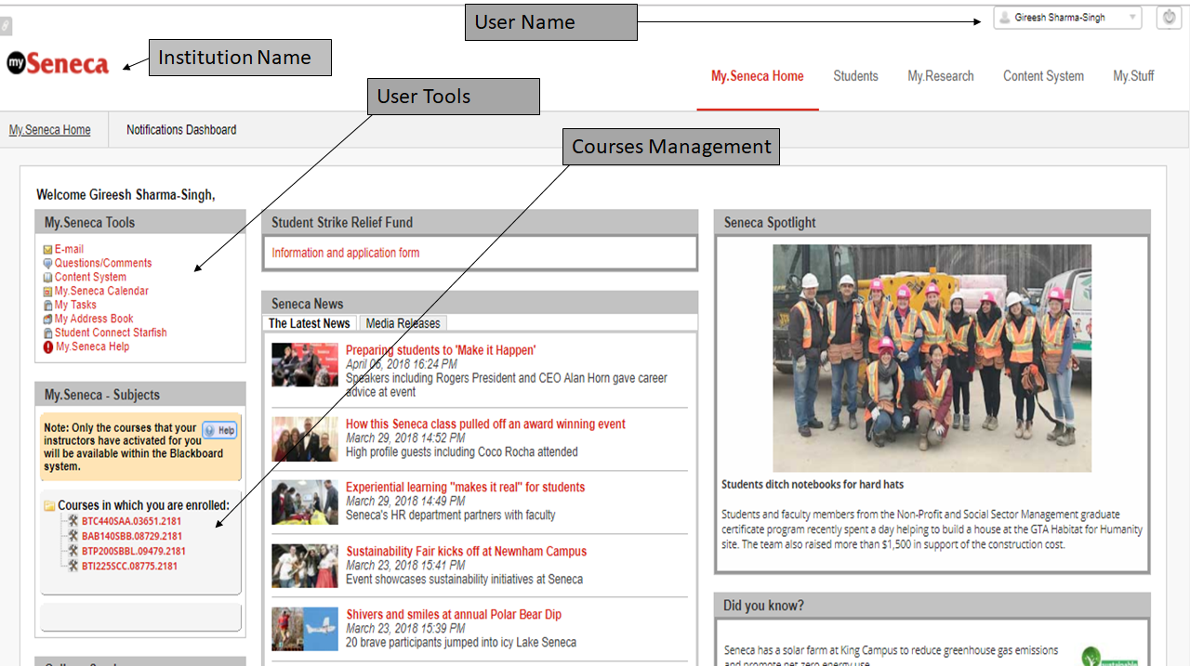Figure 1. Blackboard home page.

.

Here in Figure 2 is a class that a student is enrolled in. Blackboard allows multiple features for students and instructors to communicate. A student can also see their marks and communicate with their group members when they are assigned to a groups project. 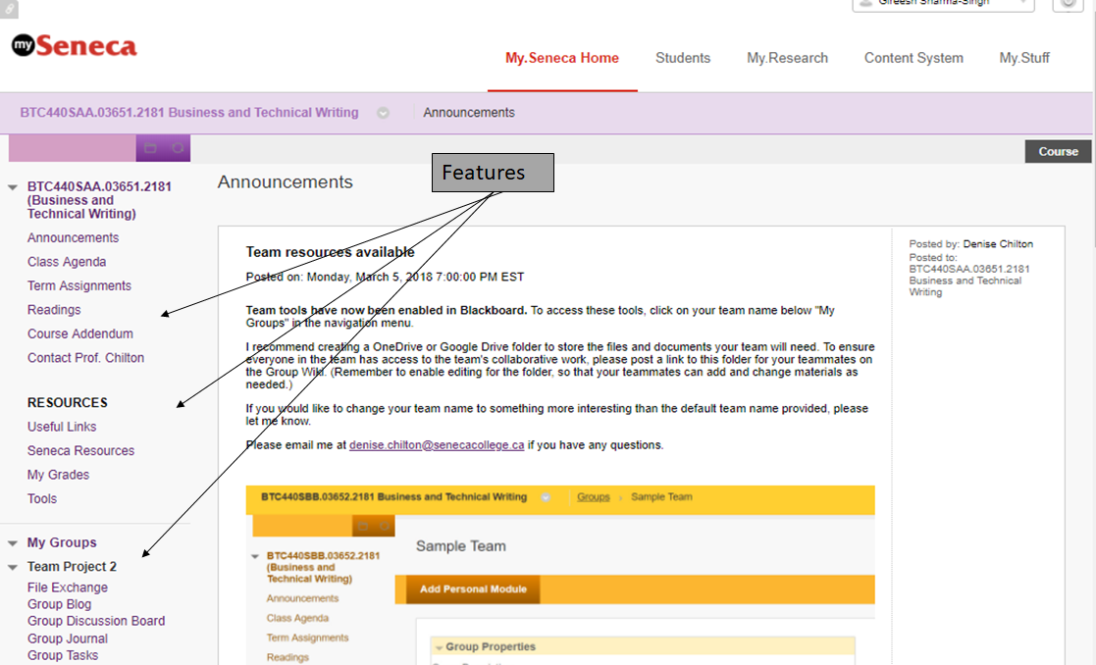

Figure 2. Class page.

Besides that, Students can also explore more powerful tools from Blackboard such as seeing their mark for the current class (under Grade section), see who is their classmates (under Roster), even have a calendar to track all the assignments and tests (under Calendar). These tools will bring not just student but also the instructor to an interactive environment where they can do much more than just learning, doing work, submitting and get grades.

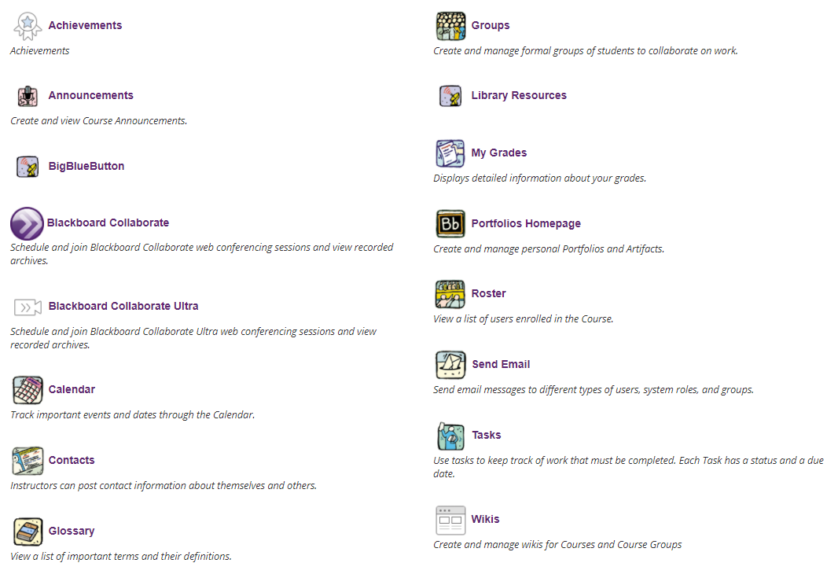

Figure 2.1 Tools sections of Class page

Setting up the class page is really easy and straightforward. As the “Build Content” tools allows for creating content on the class site. Such as class discussions, announcements and adding notes for the class to see. The instructor can even set up a link for students to hand in their work online for a particular assignment. There are many more function that Instructor can use to provide information to the online class just exactly like the way they use in regular classes

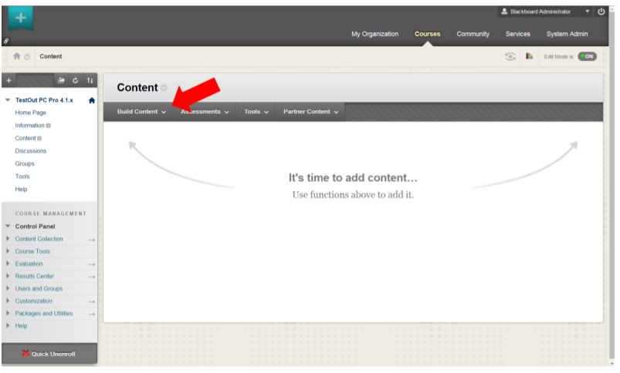

Figure 3. Creating the class blackboard site

Citations

Abdullateef, Belal, et al. “An Evaluation and Selection Problems of OSS-LMS Packages.” SpringerPlus, vol. 5, no. 1, 2016, pp. 1–35.

“About Moodle.” *MoodleDocs*, Moodle HQ, [www.docs.moodle.org/34/en/About_Moodle](http://www.docs.moodle.org/34/en/About_Moodle).

API. (2018). Britannica Online Academic Edition, Encyclopædia Britannica, Inc.  
Doyle, Charles.

*Blackboard | Education Technology & Services*, [www.blackboard.com/index.html](http://www.blackboard.com/index.html).

“Blackboard Mobile App” *Mobile App | Blackboard*, Blackboard Inc.,

<http://www.blackboard.com/mobile-learning/blackboard-app.html>

Blackboard Training & Support | Blackboard, www.blackboard.com/support/index.html.

“Blackboard LMS for Business vs Litmos LMS vs Moodle.” Blackboard LMS for Business vs Litmos LMS vs Moodle - 2018 Feature and Pricing Comparison,

www.capterra.com/learning-management-system-software/compare/14500-133660-80691/Blackboard-LMS-for-Business-vs-Litmos-LMS-vs-Moodle.

Bureau, PCQuest. “Overcoming Security Concerns When Adopting Cloud." PC Quest, 26 Feb. 2018. web 14 Mar. 2018.

Calhoun Williams, Kelly J. “Market Guide for K-12 Education Learning Management Systems.” *Gartner*, Gartner, 25 Sept. 2017.

“Connected Applications & Integrations.” *Litmos*, CallidusCloud,

[www.litmos.com/marketplace/connected-apps/](http://www.litmos.com/marketplace/connected-apps/).

“Contact Us at Litmos with Questions and Comments.” Litmos,

www.litmos.com/contact-us/.

“Discover Blackboard Channel Partner Program.” Blackboard. https://partnerportal.blackboard.com/English/Downloads/discover-blackboard-channel-partner-program.pdf

Floyd, and Miguel, Scott, Guhlin S. “Course Management Systems.” 2012, pp. 117–122.

Kavanagh, Kelly. Bussa, Toby. “ Quadrant for Security Information and Event Management.”Gartner, Web. 14 March 2018.

“Home.” *- ADL Net*, [www.adlnet.gov/](http://www.adlnet.gov/).

Ideal Personalized Integrated Educational System (PIES)." *Interactive Learning Environments* 22.6 (2014): 721-36. Web.

*“Integration Guide Labsim and Blackboard.” Labsim, 22 Nov. 2016.*

*IT Council Blackboard Learn Renewal and Expansion Pack Options*, MissoriState. 2013. Portable Document Format.

h[ttps://www.missouristate.edu/assets/ITCouncil/2013-09-10__IT_Council_Blackboard_Learn_Renewal_and_Expansion_Pack_Options.pd](https://www.missouristate.edu/assets/ITCouncil/2013-09-10__IT_Council_Blackboard_Learn_Renewal_and_Expansion_Pack_Options.pdf)

"Gamification." A Dictionary of Marketing (2016): A Dictionary of Marketing. Web.

Keramida, Marisa. “Moodle.” ELearning Industry,

elearningindustry.com/directory/elearning-software/moodle.

“Litmos LMS.” *Litmos*, CallidusCloud, [www.litmos.com/learning-management-system/](http://www.litmos.com/learning-management-system/).

“Moodlerooms.” *Blackboard*, Blackboard Inc., [www.blackboard.com/moodlerooms.html](http://www.blackboard.com/moodlerooms.html).

“Moodle vs BlackBoard – That Is the Question.” E-Learning Software, 21 June 2017,

www.ispringsolutions.com/blog/moodle-vs-blackboard/

Rice, William. Blackboard Essentials for Teachers Build and Deliver Great Courses Using This Popular Learning Management System. Packt Pub. 2012.

“SCORM Explained.” *SCORM -* , SCORM, [www.scorm.com/scorm-explained/](http://www.scorm.com/scorm-explained/).

Wallace, Susan. "Asynchronous Learning." A Dictionary of Education (2015): A Dictionary of Education. Web.

“Transform Your Classroom with Google Classroom.” *Google Classroom | Google for*

*Education*, Google, [www.edu.google.com/intl/en_ca/k-12-solutions/classroom/? modal_active=none](http://www.edu.google.com/intl/en_ca/k-12-solutions/classroom/?modal_active=none).

*What Is Blackboard | About Us Overview | Blackboard*,

[www.blackboard.com/about-us/index.html](http://www.blackboard.com/about-us/index.html).

Wallace, S. (2015). Asynchronous learning. *A Dictionary of Education,* A Dictionary of Education.

Yilmaz, Yücel. "Learning Management Systems and Comparison of Open Source Learning Management Systems and Proprietary Learning Management Systems." *Journal of Systems Integration* 7.2 (2016): 18-24. Web.

Yildirim, Zahide, Reigeluth, Charles M., Kwon, Seolim, Kageto, Yuichi, and Shao, Zihang. "A Comparison of Learning Management Systems in a School District: Searching for the

Pictures/Sources:

**Figure 1.1 –** Snipped from<https://my.senecacollege.ca/webapps/blackboard/execute/announcement?method=search&context=course_entry&course_id=_564771_1&handle=announcements_entry&mode=view>

**Figure 1.2 -**

**<https://edwiser.org/remui/>**

**Figure 1.3 –**

<https://www.litmos.com/blog/lms/january-release>

**Figure 1.4 -**

<http://www.classthink.com/2014/06/27/google-classroom-first-look/>